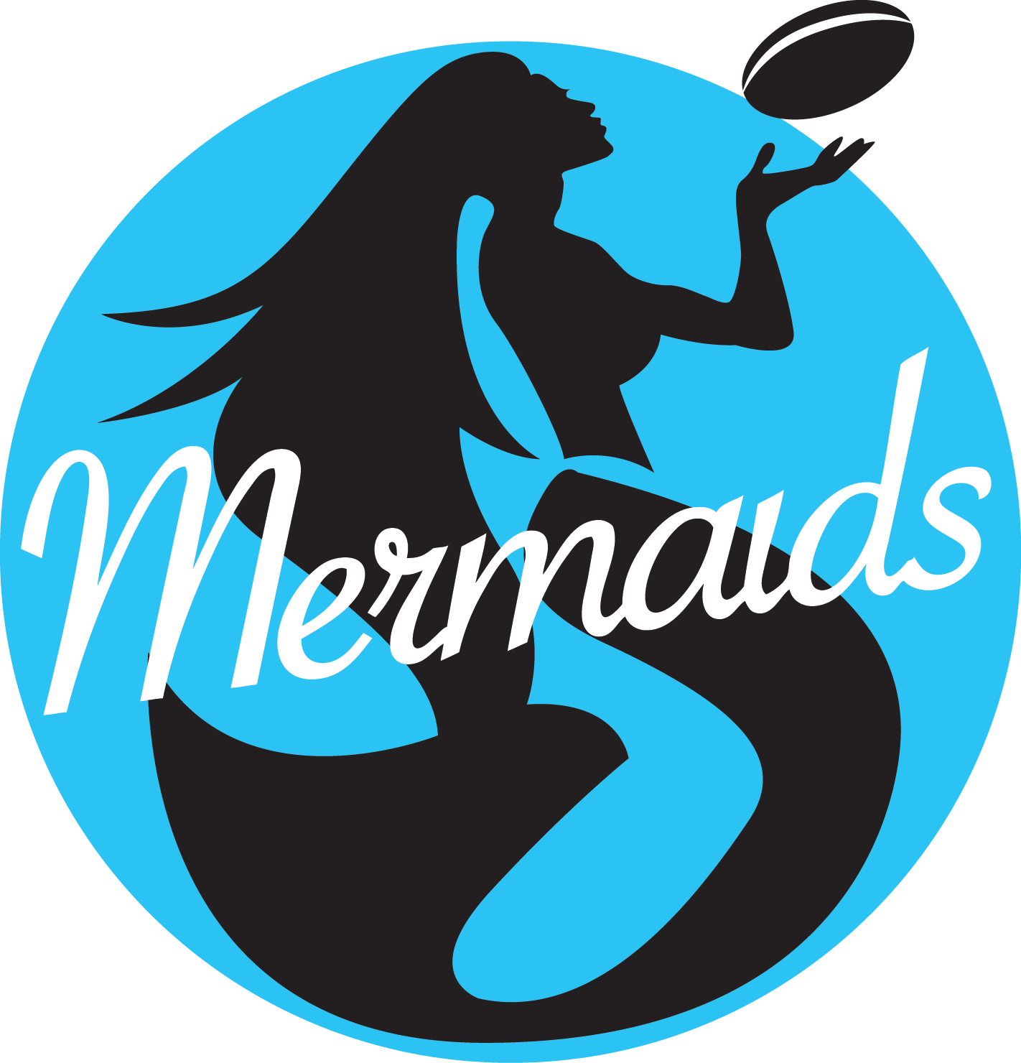

# 2026 Minespec Parts Mermaids Application

## Name:_______________________________ PH:_________________________________

**Email: ______________________________________________________**

Age:_____________ D.O.B:___/___/___

Height: _________________ Clothes size:________

Address:__________________________________________________________________

Occupation:_______________________________________________________________

Instagram Handle: _________________________________________________________

Do you have a Driver’s liicence? Yes/No

Please List your Dance Training:

**Please list skills in dance / acrobatics/ singing/ TV Presenting:**

Performance Experience (Please list if you have been a cheerleader before, which club and the years you were part of the club):

What is Unique about you?

Three words that you would use tom describe yourself:

1.

2.

3.

List community work you have been involved in?

Why do you want to be part of the 2026 Minespec Parts Mermaids?

Being a Mermaids involves being club ambassadors and working within the community. Some of the work we do is volunteer work, are you interested in volunteering your time as a Mermaid? If so, what type of work are you comforatble being part of.

Do you have plans of going on holidays in 2026? If so, what time of the year will you be travelling?

**Are you employed or studying in a full time role? If yes, where? Please list your work hours and restrictions across Monday- Sunday.**

**TRAINING DAYS**

Rehearsals will take part on Wednesday Nights from 6:15pm-8:30pm. If you are successful, you will be required to attend pre-season training from January 2026 and on Wednesday’s on the week of a home game.

Please read and sign:

* I consent Parras Productions and Cronulla Sharks to use my photographic image or words for promotional purposes. I assign any and all rights, to Parras Productions and Cronulla Sharks.
* I understand that participation to audition for the Minespec Parts Mermaids, involves risk of injury and/or loss and damage to my property and that I participate in Parras Productions and Cronulla Sharks activities at my own risk. I also release the manager and organisers from all indemnity whilst I am participating.

Signed:________________________________ Date:_____/______/_____

Fill out application form and include a profile picture.

**All applications need to be handed in by *Monday 24th November 2025***

Email application, one minute freestyle dance video and photo to:

robyn@parrasproductions.com.au

**MUST BE AT LEAST 18 YEARS OF AGE TO BE ELIGIBLE TO AUDITION**